ASSIGNMENT 2
First Year
QUESTION 1:
For a molecule with more than one conformer, the conformers lie at the minima of the energy vs dihedral angle diagram (statement A) and interconversion of various conformers needs bond breakage (statement B)
- Statement A and B are both correct
- Statement A is correct but statement B is wrong
- Statement A is wrong but statement B is correct
QUESTION 2:
For cyclohexane C₆H₁₂, the twist boat form is less stable than the boat form.
- True
- False
QUESTION 3:
Heat of combustion per methylene follows the order:
- Cyclopropane>cyclobutane>n-butane
- Cyclobutane>cyclopropane>n-butane
- n-Butane>cyclobutane>cyclopropane
- Cyclopropane>n-butane>cyclobutane

QUESTION 4:
Which of the following represents is meso-tartaric acid
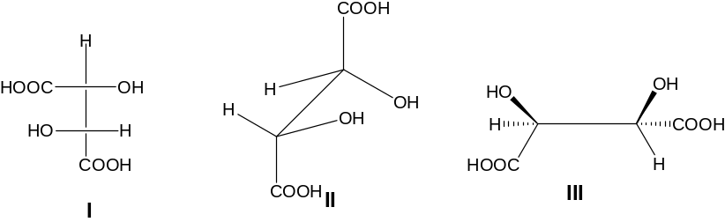

- I
- II
- III

QUESTION 5:
The number of gauche butane interaction(s) in the most stable conformation of 2,3-dimethyl butane is

- 1
- 2
- 3
- 4
QUESTION 6:
The excess energy that the following conformation has over most stable conformer of n-butane is (one gauche butane interaction energy is 0.9 kcal/mol)
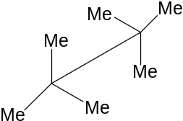

- 0.9 kcal/mol
- 1.8 kcal/mol
- 3.6 kcal/mol
- 5.4 kcal/mol

QUESTION 7:
The correct order of ease of stretching of “C=O” bond in the following molecules is
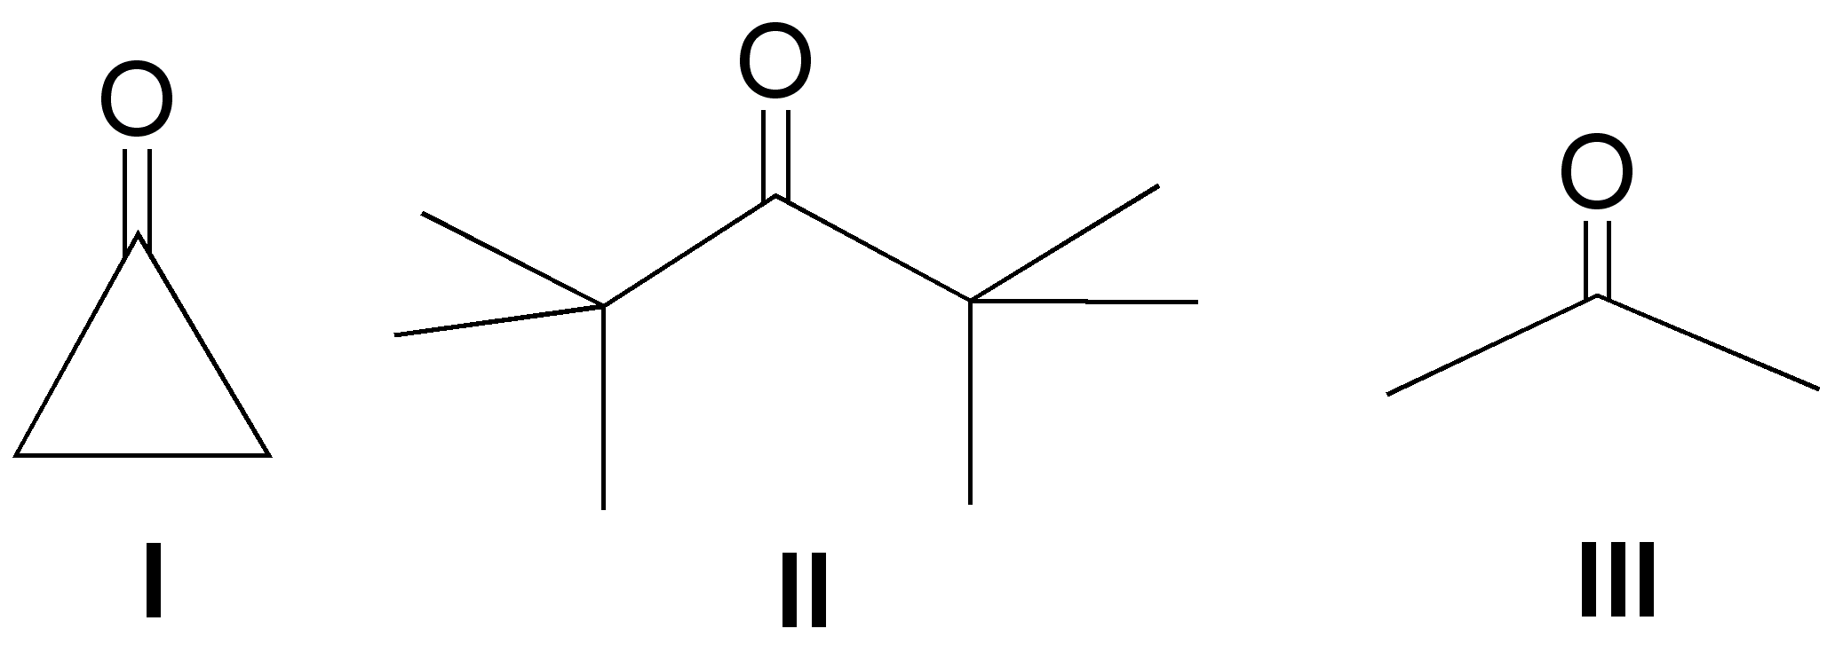
- I > II > III
- II > I > III
- II > III > I
- III>II>I
UESTION 8:
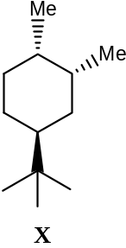In the preferred conformation of X

- Both the methyl groups are equatorial
- Only one methyl group equatorial
- Both the methyl groups are axial
==================================================================================

